Descent FreeSpace: The Great War
Reference Bible


Plot/Universe Synopsis, Species and Ship Specifications

Last updated 2/26/98, for use by potential sci-fi writers

Interplay Productions

Copyright © 1998, Volition, Inc.
All Rights Reserved

Introduction

When scientists discovered what used to be called “FreeSpace” (now referred to as “subspace”), an alternate plane of existence allowing ships to traverse great distances of space in little time, our minds reeled with the possibilities. When humans first discovered they were not alone in the universe, there was dancing in the streets.

The Vasudans had an advanced civilization, a fascinating history, and an evolved culture. They were similar to humans in many ways. Unfortunately, those similarities included irrational fear, and the willingness to sacrifice lives over politics. It didn’t take long for hostilities to break out, and for the first interplanetary war in history to begin.
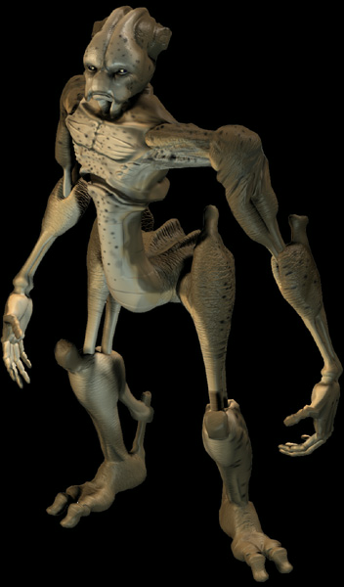

AP 2/26: We’ve kept the specifics of the start of the T-V War purposefully vague. For future elaboration in add-on disks, sequels, and fiction like this.

What started out as a show of strength and technology degenerated into a war of attrition, with both sides suffering heavy losses. Terran and Vasudan ships skirmished in remote areas of space while the politicos flapped their gums on the news. After 14 years, both sides suffered terrible losses, and the end was nowhere in sight. Until…

A distress call from a solitary fighter ship alerted Terran authorities to the existence of a third alien race. This race was not interested in negotiations, formalities, or communication. Dubbed the Shivans, after the Indian god of destruction, these aliens’ sole intent seemed the destruction of both the Terrans and the Vasudans. While the defenders hastily draw up treaties and regroup their forces, the Shivan juggernaut advances steadily on the Terran and Vasudan homeworlds. Shivan troops fly in outer space without suits, armed with a technology that seems more like magic. Meanwhile, splinter factions on existing planets take advantage of the fear and confusion for their own political gains.

Cooperation between Terrans and Vasudans seems to be the only chance they have of stopping the Shivans. But can they stop fighting each other long enough to deal with the external threat? Will even their combined might, depleted after a decade and a half of war, be enough to save their planets?
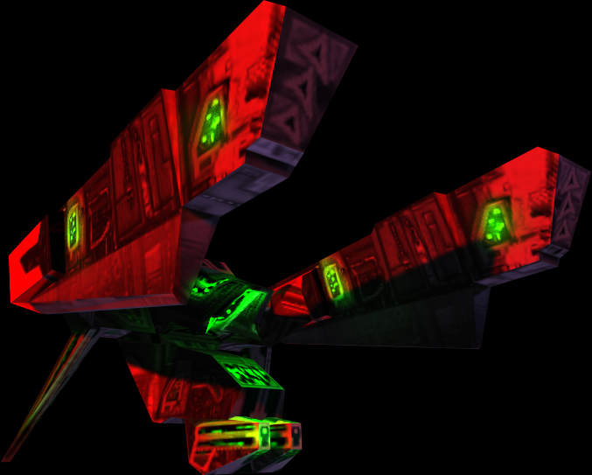

Descent: FreeSpace: The Great War is an epic story of human survival against an unstoppable alien foe. It spans 3 sapient races, over 40 different types of space craft, and countless lives. Told from the perspective of a Terran squad leader, FreeSpace is more than a war journal, it is a futuristic look at the risks and sacrifices people must be willing to make for the sake of our species.

Subspace Technology

While travel into subspace is enabled via ship-borne devices (called “subspace engines”, “cores”, or “motivators”), it’s long been known that subspace itself is a naturally-occuring phenomena.

Subspace, for the intents of this document, is an alternate physical plane of space where the normal limits of relativistic physics and travel don’t apply. By entering subspace for a relatively brief period of time, a space vessel can emerge in a location in realspace several star systems away. This technology has allowed the human race to spread across much of the known Galaxy.

There are essentially two modes of subspace travel, inter-system and intra-system.

Intra-system subspace travel is nearly instantaneous, and requires relatively little energy input to enable. Most of the GTA’s advanced fighters are equipped with intra-system jump motivators, allowing them to travel at will within a given star system. There is little or no restriction on the beginning and end points of such a subspace “hop,” except that they be in the same star system.

Inter-system travel via subspace is another matter entirely. The end points of inter-system subspace jumps are limited to the naturally-occuring focal points of subspace, also known as “nodes.” These nodes were initially discovered by Prof. J. Whiteside (see McPherson’s Multipaedia (2557 ed.), pp 1132-1140). Only between two subspace nodes is the fabric of subspace strong enough to support inter-system travel. The defense of the physical locations surrounding such nodes proved to be a central part of the 14-year Terran-Vasudan War.

In addition, such massive amounts of energy input are required to open an inter-system node, that only the largest fusion pile reactors in existence are able to sustain it. As a result, inter-system subspace travel is almost exclusively made by the largest vessels in production. This fact has made the GTA’s Orion-class destroyer/carriers a pivotal and crucial part to the GTA’s tactical forces during the T-V War.

Needless to say, the ability to deliver ships of war to nearly any pinpointed destination has forever revolutionized the concepts and long-standing tenants of space combat.

Synopsis

AP 2/26: Might want to mention here that this is basically the intro from the game. But maybe the source doesn’t matter. *shrug*

Starts off showing opening credits over a flowing color background. It starts blurry, and the source of the color isn’t immediately apparent. The credits continue for a short while as the music builds. At the same time, the flowing colors start speeding up and becoming more clear. As the credits stop, the music hushes, then the camera pulls back quickly, revealing the damaged & sputtering thruster of a Terran bomber.

The music kicks in strong again, with a frantic pace. The ship is severely damaged, and the pilot is nearly hyperventilating in panic. He’s attempting to make a distress signal, but his comm is damaged and he’s so upset he’s talking near-gibberish. Closeups of his helmeted face show that he’s sweating and wide-eyed.

Pilot: [panting] Oh god, they’re following me!… Mayday! Mayday! This is Lieutenant Ash on Terran patrol wing Gamma… three niner… reporting… taken heavy damage… requesting immediate fighter cover and rescue… come in, anybody!

Scene cuts to a nearby military installation, the pilot makes a static-filled connection with a female comm officer… begins babbling about being ambushed by some new type of fighter. The comm officer has a hard time making sense of what he’s saying.
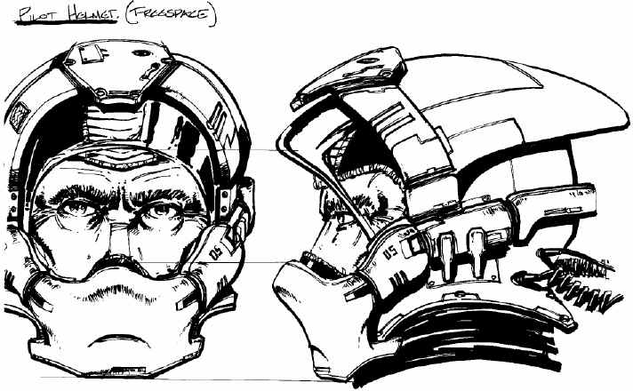

Pilot: Mayday! Requesting immediate assistance! Anyone, please!
Comm: We’re barely receiving you Gamma three niner, this is Terran outpost Riviera responding, what is your situation?
Pilot: Oh, thank god! Our wing was ambushed! We didn’t have a chance… I’m sure they’re tracking me!
Comm: Please calm down, sir, who attacked you? Was it the Vasudans?
Pilot: Vasudans were killed too, they slaughtered everyone…

Every few seconds a quick nightmarish flashback of the battle he just came from. It becomes clear that his Terran squadron was in a typical engagement with a group of Vasudan fighters when they were ambushed by several strange black-and-red fighters. The new ships made short work of the B fighters and started wasting the Terrans. Only by fleeing madly was he able to escape alive, losing his copilot in the process (he’s in one of the two-man bombers). The flashbacks show the Shivan fighters making strange, deft maneuvers, and emitting an eerie engine whine.

[cut to/from flashback]
Comm: Sir, you have to calm down. You were attacked by Vasudans, is that true?
Pilot: No, no… we were in a skirmish with a Vasudan patrol, and they just came out of nowhere and killed everyone…
Comm: Who came out of nowhere, pilot?
Pilot: I don’t know, they weren’t Vasudan and they weren’t Terran… oh, god, they had these death-black ships, and they flew like… and their weapons were too much, they wasted everyone!

[cut to/from another flashback]
Pilot: [making frightened noises]
Comm: Pilot, what is your status? We’re not receiving your data…

[Cut to pilot’s face, then to him fumbling with damage controls.]
Pilot: Status is… oh, man… [fumbling with controls… everything is damaged]… lost both stabalizers, port engine is hanging on…. [gasping]… environment controls, weapons, primary heat sink offline… subspace generator gone, O² exchangers gone, oh god… gunner is dead… he’s dead!

[cut to comm officer]
Comm: Sit tight, pilot, we’re sending a recovery craft right now.
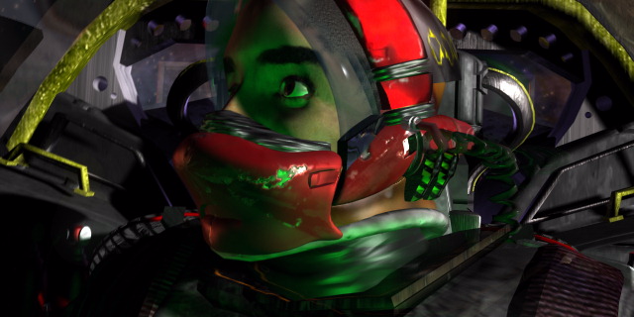
Pilot: Send fighters! I know they’re following me, send everything you have now!

[cut to pilot]
Comm: Sir, I don’t have anyone else on scope, you’re home free, pilot. It’s going to be all right.
Pilot: No it isn’t! You don’t understand, you weren’t there!

[cut to/from another flashback]

Pilot: I can feel them following me!

The pilot is soon within sight of the Terran installation. As the pilot struggles to relay his story and keep his bomber from disintegrating, many subspace holes open up in front of him, out of which streams of Shivan fighters pour.

Pilot: Oh my god! I’m dead! We’re all dead!

[cut to comm]
Comm: Picking up three unknown jump signatures. Scramble the fighters!
Pilot: It’s too late! Oh god…

[show Shivan ships emerging and going after the bomber]

[cut to radar scope. Shows huge subspace hole opening]
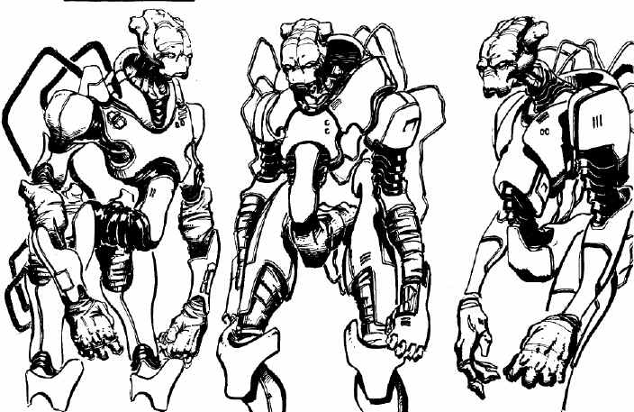
[cut to comm officer’s face, staring in disbelief]

Comm: What the hell is that?

As the Shivans turn towards the battered bomber, the pilot catches a glimpse of something huge and strange starting to emerge from a giant warp hole (it’s the SuperDestroyer). Just as the nose starts to emerge, the pilot’s bomber is hit by several missiles, blowing up in a huge flash… music reaches a frenzied peak.

[End with fast wipe; the music becomes suddenly silent and eerie.]

AP 2/26: The following bar scene is cut, and will not appear in the game. We had to several cutscenes because of time constraints. Much of the “content” and plot points of each scene are still intact in the game as text-based Command Briefings, though. I don’t know if that matters, either, just thought I’d mention it. ☺

Act 1 Intro
Scene opens with a closeup of a drink sitting in a bar. A monitor on the far side is reflected in the glass. We can see and hear a military channel newscast being made. Most of the crewmembers seen here are uniformed. It becomes apparent that this bar is on a military installation or ship of some sort. It’s dark and dingy, and people are speaking in hushed tones. There’s some goofy music somewhere. Atmosphere is pretty subdued and bleak.

[fade in to opening shot w/blurred news monitor in background]
Anchor: …the battle’s body count is estimated at five hundred and twelve Terrans dead, with twenty-nine missing in action. The Vasudan losses are unconfirmed, but are estimated at six hundred fifty. In research news, the subspace research team on the Terran science cruiser Kirillov have made a press release concerning their lack of solid findings in the past year…

Next shot shows outside of bar’s doors. The etched glass bears the name “ITA Repulse Officer’s Club”
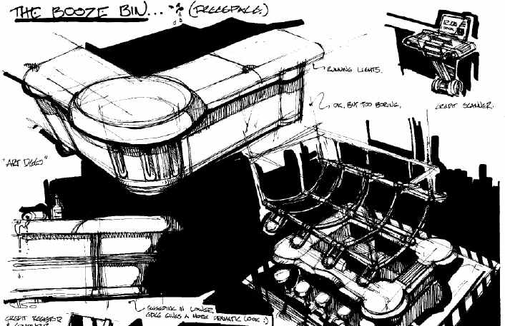

[cut to outside the bar’s doors. A doors part as a crewmember approaches, revealing the noise & such inside]

Anchor: …had the following to say in their press release.

[cut to inside shot, showing newly arrived crewmember walking to the bar.]
Scientist-XXX Since the discovery of subspace travel twenty two years ago, mankind has been able to travel and communicate over many star systems. Subspace travel and communication are used every day, by people in all walks of life. However, research into the inner workings of subspace has been making very slow progress in the past few years. While we have been able to discover the reasons subspace travel works, and how and how to develop devices to utilize it, we are still unsure what subspace really is, and why it’s there to begin with. In past centuries, people made machines based on the principles of gravity before anyone fully understood what caused it.

[cut to a couple crewmembers playing pool]
Anchor: Dr. XXX’s team was recently granted an extension on their military contract for research into subspace origins.

[cut to shot of newscast monitor over the bar]
Anchor: Two weeks ago, everyone was shocked to learn of the existence of a third sentient species. Initial enthusiasms were stifled, however, after the mysterious species proceeded to destroy several Terran and Vasudan front outposts including the Riviera, the Jamestown, and the Anatov shipyards. Little is known of their forces, but reports from the Terran-Vasudan front indicate that several outposts on both sides have been destroyed, and that both forces are retreating from the contact areas. Allied Command has classified all footage, but assures us that information will be released soon.

As the Terran-Vasudan war enters it’s 14th year, Allied Command has little to say about the overall progress of either side. While food rationing and record high death counts clearly indicate that the war is taking a severe toll on both sides, there appears to be no end in sight. That is, until this morning, when the Vasudan Ambassador submitted a formal proposal for immediate cease fire on all fronts,…
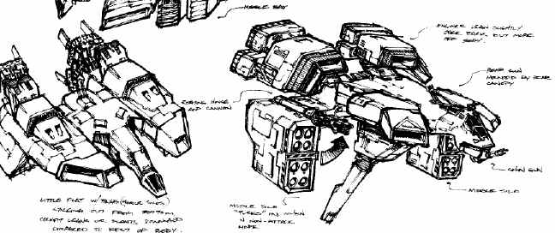

[cut to/from an officer showing shock at what he’s hearing]

…and a summit to discuss a formal treaty between the two species. An undoubtedly stunned Allied Command has issued a press release saying they are very interested in the Vasudan proposal, and deny that this is linked to the attacks from the third, as yet unnamed, species.

[pull slowly back to show the group of surprised people who have gathered around the monitor, muttering their surprise]

After 14 years of war, the sudden idea of peace with Vasuda has clearly stunned everyone.

[Missions in between these scenes mostly involve fighting groups of Vasudans that are opposed to the treaty. Later, they become an organized and formidable enemy, but they’re mostly rag-tag for now. There are an increasing number of Shivan encounters as well.]

AP 2/26: This next scene was also cut.

Act 1 Misc 1

[Fade from black into…]

The scene begins showing a dry, desert planet. Sand blows by, and it looks generally barren. It’s evening, and the night sky above the horizon is starting to show some stars. Two large moons are somewhat visible, and lights from a few ships are shown entering/leaving orbit. What appears to be the surface parts of an underground mining installation becomes visible. A large all-terrain-looking transport with cargo trailers lumbers out of a tunnel onto the surface. The camera follows it past, and a huge city is seen in the distance. The music swells up some, and a caption appears, indicating that this is the homeworld and capital city of Vasuda. Many more lights & vessels can be seen approaching the city, as well as some roads and elevated tracks.

[Cut to a closer view of the city]

A formal Terran transport ship comes into view, with many Vasudan and Terran fighters flying escort. The ship arrives at a huge building, obviously some sort of government building for the city.

[Cut to close up of top of building]

The Terran transport lands on a platform on the top of the building. After touchdown the doors open and reveal a human officer in military uniform.

[Cut to close up of officer]

This is the head of the Terran military. He pauses at the door for a moment and looks around surveying the landing pad. He then steps off the craft and is escorted inside of the building by several other Terran and Vasudan military.

[Cut to reverse of officer and party entering building]

[Cut to interior of Vasudan government building.]

The officer is now standing in a large room of assembled Vasudan dignitaries. As usual, the Vasudan carries a device on his collar that translates his soft-spoken alien speech into English, and carries the reverse translations to his earpiece. In addition there are other Vasudan and Terran military officers standing around (from the escort). The room is a diplomatic type chamber similar to a human courtroom type look although alien in design. Lots of light comes in from windows up top and banners with messages in Vasudan are flying from the walls/ceiling. Behind the row of Vasudan dignitaries are the Vasudan and Terran flags.

The officer steps up to the Vasudan leader in the center and they shake hands.

Officer: It is a pleasure to finally meet you High Counselor “AAAAAA”

Vasudan-Dig1: It is my honor Commander “BBBBBB”. This day marks a historic event in both our cultures history. We are pleased that you are finally willing to sign our peace accord.

Officer: [The captain scowls a little showing that perhaps he does not trust the Vasudans …]
I know this agreement will strengthen both of us. I only hope that by combining our forces we will be better able to stop these strange new attacks. Also, it is our desire that we will one day share our knowledge and technology freely.

Vasudan-Dig1: Yes perhaps one day in the future your people will be willing to accept the Vasudan culture with a mind of understanding instead of hatred. Then perhaps you may be able to learn from us. We will do our best tolerate our differences until you can grow to accept our people.

[This clearly upsets the Terran Commander. A closeup of his hand by his side shows him clenching his fists in an effort to control himself. It is obvious the Vasudan views the Terrans as an inferior race. He seems about to speak, but then accepts the agreement from the Vasudan Dignitary and signs it.

Officer: [The officer’s expression changes to a smile]
I hope to have the pleasure of meeting you again some day High Counselor “AAAAA”.

Vasudan-Dig1: I am sure you will. Now if you excuse me I must address my people.

With that parting comment the Vasudan turns and leaves through the back of the room with the other dignitaries following.

The scene pulls out to the bar seen in the intro. The Terran soldiers are watching the ceremony on the newscast. Camera cuts to the news anchor.

Anchor: The newly signed peace treaty will surely bring both cultures a new future. Top researchers from both races are now planning to undergo talks regarding the mysterious and deadly attacks that have taken place on both sides by an as of yet unidentified species. Coining the name “Shivans” after the ancient Hindu god of destruction, top Terran scientist Arun Patel announced plans for these cooperative Terran-Vasudan discussions to begin within the week.

In a related story, a top member of the Vasudan military, General “CCCCCC” has apparently mutinied from the main Vasudan command. Stealing several Vasudan warships and pilots he sent this announcement earlier today to both Terran and Vasudan leaders.

Cut to shot of radical Vasudan leader. Video is somewhat noisy. The translation is either voiced over or shown as text on the bottom.-

[Radical Vasudan is seen in a medium closeup in a room of a dimly lit spaceship interior somewhere. He gestures with wide flowing poses as he speaks. He’s not an arm-swinging fanatic. He speaks in calm tones and has a peaceful demeanor.]

Rad-Vasudan: …the sudden appearance of this new race is direct proof of the ancient prophecy! All Vasudans should join together to await the great cleansing! Those who deny themselves this great moment of truth shall surely regret it! My family…pay heed to the ancient texts…open your minds and join me! Together we shall honor our new masters and enter the wonderful gate of the future!
[Cut to anchor]

Anchor: The arrival of the Shivan forces was heralded in the prophecies of the Vasudan people. The prophecy promises of an natural “cleansing” force that will overwhelm the Vasudans and their allies, preparing the way for a new age.

Vasudan dignitaries have condemned “CCCCCC”’s statements as that of a madman. They say the radical movement is embracing the wide-eyed mysticism of their species’ history that most of their people have long-since discarded. The Vasudan government has issued a strict warning to the defectors that if they don’t stand down, military action may be taken.

With the Allied Forces News Watch I’m “DDDD DDDD”.

AP 2/26: This next scene did not get cut, fortunately. It was moved to be the Act 2 intro, or thereabouts.

Act 1 Misc 2

Scene opens with a medium long shot of a damaged Shivan freighter floating in space. Several smaller Terran and Vasudan ships fly by in formation. As the camera/Shivan ship floats we notice a Terran transport docked to a section of the disabled Shivan craft.

[Cut to…]

Interior of a control room/console. Several monitors have vital stats like heart-rate, etc displayed. Others show noisy shots of the interior of the Shivan freighter (coming up). One or two characters sit in front of the units. Over the consoles speakers we hear:

Soldier-1: Control, this is boarding party Bravo-2. We are entering disabled freighter now.

Control-1: Roger Bravo-2. You’re reading 7 by 7. (This is actually a real radio rating used to measure quality and readability of a transmission-MC)

[Cut to interior of Shivan ship. ]

We see Medium shot of Soldier-1 posed by a wall. As camera pans we see several other soldiers taking up positions in a corridor. All soldiers are carrying some form of advanced weaponry as well as a microphone unit attached to their helmet/head. The interior of the ship is dark and has obviously taken heavy damage. Sparks fly in several areas from damaged conduit lines.

Soldier-1: Ok control, we’re proceeding with the boarding operation. Zombie…Flex… Go!

[Cut to reverse of Soldier-1, we see 2 other soldiers move up to the front of the part around a slight bend]

Zombie: [nervously] No sign of anything. No life, nothing.

Spice: Take it easy now, don’t get trigger happy.

Flex gives a hand signal

Flex: We’re in position.

The other soldiers move up.

Zombie: Ok. Spice, take rear. Zombie, Flex, Smasher….move in.

Spice: Damn it’s cold in here. Still no sign of gravity, either. We must have really nailed this puppy.

Zombie: We can freeze dry them when we’re finished. [giggle]

Soldier-1: Cut the chatter, damn it!

Flex: Probably all dead anyway.
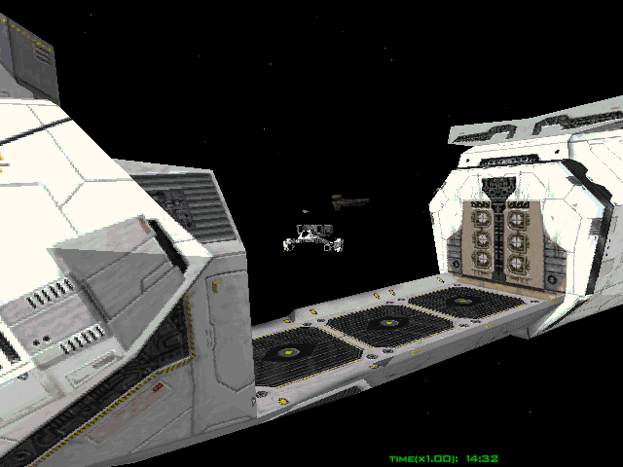

Control-1: Bravo-2 , your signal is getting weak. Boosting power to your com-cells.

Soldier-1: Roger, control, everything looks clea….

There is suddenly an odd scratching / hissing? sound from the far end of the corridor.

wait! Everyone hold! Hear that?

Everyone stops and listens.

[Cut to interior control room]

Control-1: What’s going on Bravo-2? We don’t see anything unusual.

Soldier-1: I’ve got an audio contact, about 30 meters away, straight ahead. Form up, everyone!

[the Terrans huddle up somewhat, looking forward towards the sounds. Some kneel down and brace their weapons.]

Soldier-1: It’s too dark to see though….. Zombie can you make out anything?

Zombie: Negative cap…..whoaaaaaaaa!

Emerging from the dark end of the corridor come 3 Shivans. They are huge, easily towering over the soldiers. They move both by jumping/walking and grabbing onto the ceiling, unhampered by the zero-g.. They approach the boarding party but stop about halfway. They pause and appear to be studying the Terrans. They carry no discernible weapons.
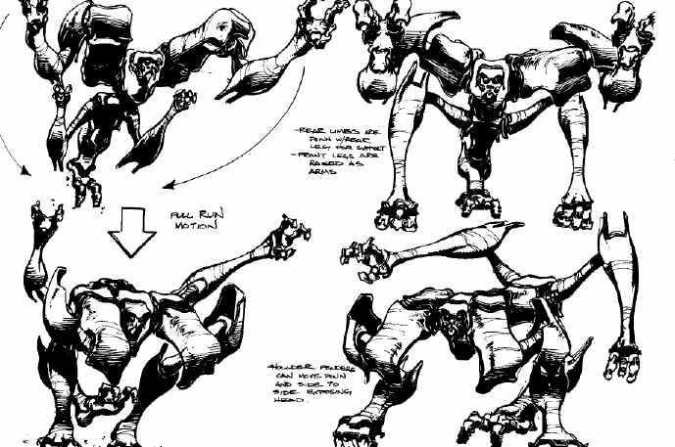

[closeup of the front soldier’s eyes over his gunsight, as they widen in shock]

Spice: What the hell is that!

[cut to medium shot of soldiers]

Flex: Oh my God…. look how they move….
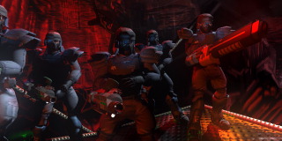
[brief pause, as the Terrans recover from shock]

Soldier-1: Open fire!

Massive automatic gunfire erupts from the Terrans. The Shivans react very quickly and start to jump toward the party.

Zombie: *screaming* Die!

[Cut to closeup of a Shivan bounding towards the Terran unit. It’s visibly taking the brunt of the Terran’s firepower, and goes down about 8 meters away. The two behind it quickly bound around/over it and continue on, undamaged.]

They each swing an arm and odd protrusions appear. They appear to be energy blades of some sort.
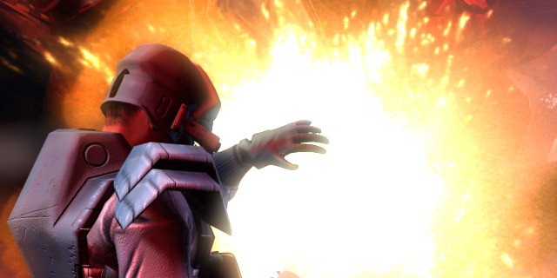
[Cut to reverse of Shivans coming down on Terrans.]

The Terrans start screaming as one of the Shivans jumps directly on one of the soldiers and nearly slices him in half with the blade. The other one bounds over the first and starts mauling the remaining 2 soldiers.

Soldier-1: Fall back!

Spice: Too late!

Control-1: What’s going on?!? Please respond!?

A Shivan now pounces on Soldier-1 throwing him into the side of the corridor as it lands.

Cut to reverse of Spice backing up slowly. She has stopped shooting and is nearly frozen with terror. The closest Shivan turns and sees her. Camera zooms into it as it turns and rotates an appendage. An odd hole opens up.

Spice: *quietly* no …..no….
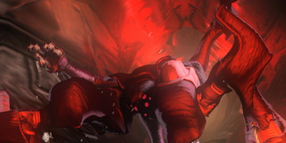
Control-1 Bravo-2 this is control! Do you read! Please respond!

The Shivan then unleashes some kind of energy bolt from the opening in its arm which totally annihilates Spice into some cool electrical/explosion/particle effect.

[Dissolve to White from explosion….]

AP 2/26: That’s the end of the scene. The remaining parts of this scene are cut

[Fade from White into….]

Interior. Several Terran and Vasudan scientists are working in some type of laboratory. There is a center work table with various fragments from Shivan ships on it. Along one wall are several computer terminals. Along another wall is some unidentifiable research equipment. (Think futuristic physics lab). Some of the scientists are fiddling with the research stuff. A Terran scientist sits at one of the terminals, with a Vasudan looking over his shoulder.

All scientists wear some sort of badge stating their name, clearance level and title. The Vasudan peering over the terminal is listed as being a visiting scientist.

The camera shows a medium shot of the two scientists at the terminal, standing near a small enclosed test area. Energy & light flickers from inside the test enclosure.

[watching monitor together]

TerranSci-1: You see from this part of the captured ship breakdown the energy flow is constant.

VasudanSci-1: Yes…but how do you explain what happens during a jump? It doesn’t seem as if the rate is sufficient to support the required level.

TerranSci-1: Very good observation “EEEEE” You live up to your credentials. You see…

[walking to another monitor]

The Terran gets out of his chair and the Vasudan follows him over to the research equipment where the other scientists are tweaking things.[possibly cut this part if we don’t want to show more scientists]

[cut to monitor displaying some sort of graphical test readouts]

TerranSci-1: We’ve been able to get a prototype shield system working under normal conditions. However when we simulate jump phenomena there’s no way to keep the power levels high enough.

VasudanSci-1: But under normal conditions the shields actually protect the inside structures?

[cut to show both scientists]

TerranSci-1: Correct. They stop almost all damage from getting through, at the cost of energy, which explains how the Shivan ships have been able to defend against our attacks so easily. Despite its shortcomings in subspace, we should be able to start producing shield systems for use on our ships.

VasudanSci-1: Excellent…that should give them quite a surprise. What about their weapons?

TerranSci-1: Unfortunately we have not gotten very far with their weaponry yet. But we have noticed they leave a cloud of negatively charged meson particles around after they fire. We’ve been able to verify that at several recent encounters.

VasudanSci-1: You can determine if a battle has occurred at some point in space afterwards?

[cut to shot of them walking slowly around the area]

TerranSci-1: Yes. But there’s something odd. We recently ran a test at the Riviera outpost by SR-5…or rather where SR-5 used to be… The levels of meson particles there was far higher than expected compared to most data. Even for a large battle the level was extreme.
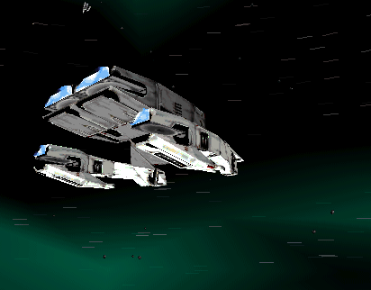
VasudanSci-1: Possible is it the sensors were not functioning correctly? [talks like Yoda here. ☺]

TerranSci-1: Yes. We’ve ordered another sweep of that area, but it will be several days before the next science vessel can complete the test. Until then we’ll continue working here with what we know.

VasudanSci-1: Very good.

[fade out to black]

[fade in to newscast at bar again]

Anchor: A joint scientific effort between Terran and Vasudan forces reached a breakthrough this week with the development of a prototype energy shield system. Current Terran and Vasudan forces are now being outfitted with units that protect the ship from taking damage directly. However, researchers state they still have much work left ahead in trying to learn more about the Shivan forces.

[cut to closeup of newscast only]

The Terran and Vasudan Joint Advisory Council also held a meeting this week. Members are disturbed that no communication has been made with the Shivans. Nor has any communication been detected between the Shivans themselves. It’s obvious that no one knows why the Shivans are attacking and what they are after. Also discussed was the growing threat from radical Vasudan leader “CCC CCCCC”.

[show images of leader, inset into newscast]

Recent skirmishes have broken out between both Terran and Vasudan forces and the radical Vasudan movement now termed “Hammer of Light”. Leader “CCCCC” has apparently called for hostile action against those who deny the doctrine in the ancient Vasudan prophecy.

We’ll have more news after this…

AP 2/26: This next scene is intact.

Act 1 Misc 3

This scene is what I’m calling a “command brief.” It’s basically a scene with a bunch of pilots getting information from their commander before a series of missions. It’s a relatively cheap way to deliver a lot of info to the player. The scene shows mostly the backs of the pilots heads, with their Captain standing up front, facing them. He’s got a large screen that shows data and other things as he talks about them. We can maybe intermix the dialogue with the occasional reaction shots of the pilots.

[Fade in shot from rear of room. A couple pilots are just now sitting down.]

Captain: Good morning, pilots! I’m going to get right to it. The Shivan forces are sprouting up everywhere, and it’s no secret that our front lines are taking a beating. As you probably know, no one has been able to communicate with them, and Terran Intel has no leads on their origins or their motives. On the upside, their shielding technology seems to be working just fine for us. By this afternoon, all fighters stationed on the ZZZZZ will have been fitted with them. Try to keep them intact, all right?

The Shivan Cruiser Taranis is suspected to be a source of command for the Shivans in this sector. It’s here in the Ikeya system, and we suspect that it’s low on fighters and supplies due to its recent attack runs. We have reason to believe it will soon jump to another system to resupply. We don’t know where it will jump to, but there is only one known subspace node out of Ikeya, and we intend to blockade it. In the interest of learning more about the slippery bastards, we’re going to attempt something bold… the capture of the Taranis. [crew mumbles with excitement]

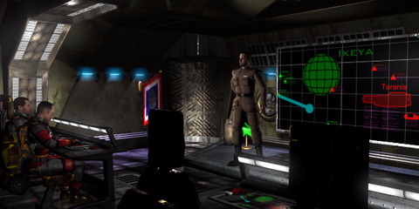
[cut to medium profile shot of Captain]

If this goes off, it will give us an opportunity to study Shivan technology up close, and bag a few live Shivans in the process. [muttered enthusiasm from pilots] In order to do this, we will conduct a series of missions designed to take out the Cruiser’s escorts and defenses. Time to chip away at the boulder, people.

That is all. Report to your flight leaders for your orders. Dismissed!

[fade out]

In the next couple missions, the player’s flight group will assigned to the task of weakening/destroying the ships accompanying the command cruiser.

AP 2/26: This next one is cut totally ☹. The events there are discussed in a Command Brief screen, however.

Act 2 Intro A
This scene shows the capture and eventual destruction of the Taranis cruiser. It also shows the SuperDestroyer in its entirety for the first time.

[cut to anchor doing live news coverage]
Anchor: We’re now going to the science station Tombaugh in the Ribos system where a team of Terran and Vasudan scientists await the arrival of a recently captured Shivan D-class Cruiser. It’s being escorted by the Terran Destroyer XXXX, which conducted the attacks and capture operations over the course of three days.

[cut to Cruiser & Destroyer arriving through subspace holes, viewed from a large window on the science station. The newscast can be dimly heard in the background.]

Terran-1: [approaching window and pointing] Whoa! There she is!
Terran-2: [joining first Terran at the window] Look at that!

[two others join them at the window]

[cut to close shot of the two big ships leaving subspace, with many fighters flying escort. Some battle damage is seen on the Taranis]

[cut to reverse shot of ships approaching station]

[cut to shot over the shoulders of the Terrans clustered around the window. They’re cheering and acting very excited]

[cut to shot of nearby comm officer]

Comm Officer: Roger, this is Tombaugh station, XXXX, we have you. You’re now cleared for approach at pylon S1…. stand by for ADT transmission.

The comm officer’s station begins to flicker. Power is failing, and the instruments are struggling to retain their displays.

[cut to window shot again. Terrans are looking around at the failing lighting systems, making puzzled noises. Comm officer can be heard nearby, trying in vain to regain contact with the approaching ships]

[cut to exterior shot showing both Destroyer XXXX and the science station. Lights can be seen failing across both, leaving them black.]

[cut to another view showing some escort fighters losing power and starting to list aimlessly]

[cut to comm officer shot again. She’s working in darkness, trying to raise the XXXX on her comm]

Over her shoulder we see a huge warp tunnel begin to appear. It’s blood red and much larger than any subspace hole’s seen so far. The crew gasps in shock, wondering what it is.

[cut to closeup of emerging SuperDestroyer. Show tons of fighters spew from it’s bays before it’s even emerged totally. The SD mows over a couple Terran fighters floating in its way.]

[cut to shots of Shivan fighters blasting the helpless Terran fighters, pilots yelling]

[cut to shot of SD passing by the captured Cruiser. Watch as the shadow passes over the side of the station]

[cut to forward shot of the crowd at the window, as the shadow passes over them, they stand there in awe]

[cut to shot over their shoulders, as the SD passes very close to the Cruiser and station. Members of the assault team on the Cruiser point at different parts of it, muttering. The SD gradually slows to a stop.]

[cut to under shot of the SD’s big gun array. It starts to reconfigure and “draw light” to itself.]

[cut to shot of one crewmember]

Crew-1: Oh, no! [like he/she is the first to realize what’s happening]

[cut back to gun]
A huge energy beam blasts out from the gun!

[cut to shot of beam tearing into the Cruiser as it gets thrown back from the blast]

[cut to shot of assault troops at window, being thrown against the window from the impact]

[cut to shot of beam making its way across the Cruiser, slicing it up]

maybe: [cut to angle showing Shivans leaping from openings in the SD (without suits!)]

[cut to interior of cruiser where the crew was]
Through the window we can see the beam approach this room. The crew is running around madly, but the wall erupts and they’re all incinerated in a split second. Come up with some cool incineration effect here.

[cut to medium shot of the two ships]
The beam is cutting through the far side of the Cruiser, and it’s hull is buckling and breaking up.

[cut to interior shot of Shivans boarding and tearing up some Terran crew]

[cut to shot of a floating Terran fighter]
The battle is reflected in his canopy. He’s watching helplessly in wide-eyed fear]

[cut to reverse shot, showing his POV]
A couple seconds of battle can be seen before a Shivan fighter spots him, aims, and blasts him to hell. The screen goes black.

Act 2 Intro B
This will be very much like Intro A, but will have the following differences:
- Instead of returning victorious with the captured cruiser, the Terrans will return defeated to regroup (near the same installation).
- The SD will arrive still, but instead of watching in awe from the Cruiser, the Terrans will watch in awe from the installation.
- Instead of blowing the Cruiser to hell, then the installation, the SD goes right for the installation.
- all else is the same, and many scenes will be identical.

[Missions here will have to do about covering the retreats on nearly all fronts. Some offensives can be worked in here, though, I’m sure.]

AP 2/26: Next bar scene is cut.

Act 2 Misc 1A

Scenes opens with a shot of the bar used earlier. There are two Vasudans at a table close to the bar. The table next to them has two Terrans drinking. The scene opens with a far shot and then cuts to a close up of the two Terran pilots in the midst of conversation.. A newscast hums on in the background.

Will: I dunno Jake. I just think that you’re a damn pessimist.

Jake: Oh come on man! How much will it take before you realize how badly we’re doing! I mean our butts are getting kicked! Just look around…we’ve got more refugees from surrounding colonies than trained pilots here! Did you hear about that huge Shivan Destroyer that popped up and nailed Tombaugh station and that Cruiser we captured? Didn’t stand a chance. All that’s left now is a bunch of scrap metal and vapors…

Will: Oh there we go….more rumors…

Jake: I’m telling you it’s true…I heard from a good source, he said he’s seen the footage! You know what I think. I think it’s those damn cow-faced Vasudans… You know they’d just love to kill us all. You know if the Shivans hadn’t shown up, we’d still be blasting them out of the sky!

Will: You really think so don’t you? If that’s the case then why are their scientists helping us out?

Jake: Helping! They’re probably studying us…taking notes. Trying to figure out how to hit us after the Shivans are gone. That’s why everything is so damn ominous here! [Jake gets a little louder] We’ve got to share our quarters with those damn snot nosed sand crawlers!

[This gets a look from one of the Vasudans at the other table. They look for a moment but then ignore the Terrans and continue talking…]

Will: Jake, keep your voice down! I agree that morale does seem to be a bit low here…but that doesn’t mean we’re losing because of the Vasudans. Everyone’s just getting tired of fighting is all…

Jake: Oh yeah, tired. Tired of losing battle after battle. Tired of seeing their best friend become a piece of space debris. Tired……tired….

Jake suddenly gets quiet and looks at his glass. We hear the newscast clearer as they both look up at the monitor.

[Cut to closer shot of monitor]

Anchor: Early last night the Terran shipyard outside of the Rodine System was destroyed by unknown sources. Apparently a distress signal was sent, but by the time support arrived the attackers had left the area.

The Vasudan “Hammer of Light” group has claimed responsibility for the attack stating that all those who fight the Shivans are resisting the divine plan. However military officials state that there is no proof the radical movement was involved.

[The newscast continues as Jake starts up again]

Hammer of Light leader “CCC” issued a statement to the….

Jake: See! It’s those damn sand eating bastards! I tell you man. We ought to kill em all. They’re causing more trouble than the Shivans.

Will: I don’t know about that, Jake. I’ve heard some evil shit about the Shivans…

Jake Oh they’re all in it together. First those stinking Shivans show up. That’s why they signed that treaty. They knew they would lose. They’re in it together I tell you.

[The two Vasudans look over again]

Jake: Yeah buddy! What are you looking at?…

[You see the two groups eyeing each other suspiciously as the video fades to black]

[Missions after this scene concern covering the retreat of a Terran Cruiser and its escorts to an alternate system.]

AP 2/26: Also cut. In fact, all scenes following this are cut except for the endgame cutscene, which is intact. Also intact are the 6 “Ancients” readings that explain the life and downfall of the Ancients that discovered the Shivan weaknesses. I’ll include the text from those at the end of this section, but before the Species Descriptions.

Act 2 Misc 1B

[Same as A, but the hard stares to the Vasudan’s table ends in violence. Act 2 Misc 1A continues from the two parties staring at each other here:]

Vasudan1: You have a loud mouth, human. If you knew the truth you would not say such things.

Will: Hey man…he just had a bit too much to drink…give him a break.

Jake: Yeah! Give me a break! In fact I’ll tell you what. Why don’t you come over here and I’ll give you a break! I’ll break your face into little alien pieces and flush it down the toilet!

[Jake gets up and nears the other table. The two Vasudans stand. Will mumbles something but then gets up too…]

Vasudan2: You should leave now.

Jake: Me leave! Ha! This is our damn ship you stupid bastards! You think you own it! Here own this!

[Jake takes a swing and hits the Vasudan. The other Vasudan starts to fight with Will. The fight starts up and we heard shouts in the background as other people get involved. The camera cuts to the anchor as we see a shot of the radical Vasudan leader giving some speech and the scenes fades out with the fight sounds in the background.]

[Missions after will cause the Cruiser to become crippled, and the player will then have to escort escape transports as they flee the dying ship].

Act 2 Misc 2A
Command brief. This is a longer one that focuses on Shivans.

Captain: Pilots, I have some grim news. Terran intel has spent the last two weeks analyzing flight data from the Tombaugh station attack. The data on the Shivan SuperDestroyer has been given special attention, and intel believes that the attack force had been tracking the XXXX and the captured Taranis Cruiser through subspace to the station. [some murmuring here]

Intel doesn’t know how they did it, but they’ve got a team of engineers trying to find out. They’re also analyzing the new shield system the SuperDestroyer is using. It doesn’t appear to be vulnerable to any of our weapons. Hold on, it gets worse.

[show monitor map behind the captain]

If you look here, you’ll see that with the loss of Tombaugh Station, the Shivans gain control of this subspace node. That leaves only two subspace jumps between the SuperDestroyer fleet and the home system of the Vasudans. It’s in our best interests to defend Vasuda Prime, yes, but if the Shivans gain control of that system, it will be a short walk to Earth itself. [everyone sounds surprised/worried]

[diverging point for Misc 2B]

This may not be as bad as it seems. There are a dozens of star systems off of that node, and we have no reason to believe that the Shivans know which one our homeworld is in. It is obvious, however, that they are narrowing it down, and we can’t afford to give one more inch up.

We’re going to move the fleet in between the Shivans and Vasuda Prime. Command is sending the newly commissioned Bastion with its fleet to help us with the blockade, but for the time being we’re the only defense. Report at fourteen-hundred for your mission briefings.
[fade out]

Act 2 Misc 2B
Same as first part of A.
Last part differs in that the jump point is already being blockaded by Shivans, and your Terran fleet must attempt an offensive to reclaim it.

[pick up where 2A diverged]

Captain: This may not be as bad as it seems. There are a dozens of star systems off of that node, and we have no reason to believe that the Shivans know which one Earth is in. It is obvious, however, that they are narrowing it down, and we can’t afford to leave this node in Shivan control.

Act 2 Misc 3A
Command brief.

Captain: Let’s get to it, pilots. Because of our fleet’s position, we’re assuming that the Shivan SuperDestroyer fleet will show up at any time. Instead of idly waiting to get jumped, we’re going to make a few sorties to scout the nearby systems, and hopefully get some information on their fleet’s defenses.

Intel still has no firm information on the SuperDestroyer’s shield system. When it attacked the Vasudan outpost in the Diones system, they tried three different missile prototypes, with no luck whatsoever. Whatever shield system they’re using on their flagship, it must not be an option for the smaller fighters. Those continue to use shields that can be defeated with sufficient firepower.

While the scout sorties are made, we will be making small maneuvers designed to mask the position of our blockade. Although at this point we’re merely making educated guesses at the Shivans’ tracking abilities. Dismissed!

Act 2 Misc 3B

Captain: I’ll make this quick. We’re under general quarters because a group of patrol fighters report that the advance ships from the SuperDestroyer fleet are approaching our blockade as we speak. ETA is thirty-five minutes, so when you leave here, everyone needs to report to their wing stations for mission briefings. The SuperDestroyer itself is behind the vanguard force, but we can expect it to make an appearance at any time.

Intel still has no firm information on the SuperDestroyer’s shield system. When it attacked the Vasudan outpost in the Diones system, they tried three different missile prototypes, with no luck whatsoever. Whatever shield system they’re using on their flagship, it must not be an option for the smaller fighters. Those continue to use shields that can be defeated with sufficient firepower.

[In these missions, the player’s Destroyer & supporting fleet gets wiped out]

Act 3 Intro A
Open with shot of a the Terran Destroyer Bastion. It’s now the home of all the pilots left stranded after the destruction of the XXXXX. The briefing room is similar to the other one, with some small changes here and there.

[fade in shot of Bastion, with caption]

[cut to briefing room shot, with a new Captain in front of everyone]

Captain: At ease, pilots. I’m Captain Shima, and I’ll be delivering your command briefs while you’re onboard the Bastion. I extend a welcome to all pilots formerly stationed on the Repulse. I wish your reassignments could have come under better circumstances. I know the loss of the Repulse is a great blow for all of us, and with it, we’ve also lost many friends and loved ones. We’ve also lost many great pilots, and we need to double our efforts here if we plan on stopping the Shivan fleet.

Which brings me to the reason for this brief. As some of you may have heard already, shortly after the destruction of the Repulse at nineteen hundred last night, we received word that the Shivan SuperDestroyer fleet made the jump to Vasuda Prime. The SuperDestroyer fleet bombarded Vasuda Prime from orbit for thirteen hours straight.

[cut to closeup of her monitor. Shows grainy/static-filled footage of the SD blasting at the planet from orbit]
All escaping transport ships were destroyed. All major Vasudan cities were leveled, and most of the landmass was made uninhabitable. All of our attacks launched from the nearby installations were defeated. We’ve lost contact with all other Terran ships in that area, but it appears that the Shivan fleet has now moved on. It’s estimated that four billion innocent Vasudans lost their lives in the attack. Terran Command is planning to evacuate all survivors on Vasuda Prime to another habitable world.

If there’s a positive note to be had here, it’s that we now have a wealth of data on the Shivan’s attack patterns to analyze. Terran Intelligence feels it’s significant that the Shivans made this attack entirely from orbit… not a single ship landed on Vasuda Prime. We will relay more information as we have it.

What we need to concentrate on now is keeping the SuperDestroyer fleet from making further moves towards Earth. We’ve put together a series of missions designed to weaken the Shivan fleet’s defenses and support. Report to your wing stations for immediate briefings. Dismissed!

Act 3 Misc 1A
Command brief.

Captain: A Terran listening outpost in a nearby system received this transmission at oh-nine hundred this morning…

[lights dim, wall monitor begins showing a grainy transmission. It’s a Vasudan]

Vasudan: We are a group of Vasudan refugees seeking the assistance of any Terran ships. We were onboard a Vasudan science outpost when it was destroyed by the Shivans. We managed to land on this uncharted planet when our escape pod lost power. It’s uninhabited, but we uncovered the remains of an ancient civilization. They were neither Terran nor Vasudan nor Shivan.

Our scanning equipment was able to locate a storage device of some sort. It was heavily protected, which suggests it stores something quite valuable, possibly information or technology. We are attempting to decipher the language of the device, but are fearful of Shivan attacks.

I say this because it is immediately apparent that this planet was also destroyed by Shivan weapons. This is difficult to believe, considering the age of the remains, but the evidence is conclusive.

What we ask is for rescue and an escort away from this planet. Our scientists are not normally a superstitious group, but having one’s homeworld destroyed tends to shake your beliefs. Please send an armed rescue as soon as possible to these coordinates.

Command brief. A message from a group of Vasudan refugees was sent to Terran Command. They discovered the remains of an ancient alien civilization. From the condition of the remains, it appears they too were wiped out by the Shivans ages ago. After an extensive search of the destroyed city, the Vasudans discovered a small set of science records made by a group of their scientists. They’re currently attempting to decipher their technology and language, and are fearful of Shivan attacks, but suspect that the records may contain valuable information about the Shivans. They request immediate help from the Terrans in evacuating the logs so they may be analyzed in safety.

The player is assigned to a small attack group sent to recover the records.
[next missions involve him going to/returning from the planet]

Act 3 Misc 2A
The records have been deciphered and analyzed. The language used by these “ancients” bears several similarities to the Vasudan language, lending credence to some of the Vasudan legends about their ancestry. From what little information there is in the records, it’s learned that the Ancient’s civilization was one very similar to the Terrans and Vasudans, and that they were likewise annihilated by a mysterious space-faring race that showed no mercy or effort to communicate. In the last months of their species’ existence, they were perfecting a device to allow ships to be tracked in subspace. The Ancient’s planned on using this to attack the Shivans’ key ships in subspace while their shields were down. Unfortunately, the Shivans destroyed their fleets before they could exploit this device. Furthermore, the Ancients speculate that subspace nodes were quite fragile, and that combat during a jump would surely cause the collapse of the surrounding nodes.

Terrans begin constructing the tracking device immediately. They need to recover certain bits of technology from the Shivans to reconstruct the tracking device. The renegade Vasudans also have a piece of needed technology so there is also an offensive against them, requiring a showdown between the renegade and loyal Vasudans.

[missions involve the player’s forces trying to track down the SD fleet. It’s found, and the newly made tracking devices are readied for use. Unfortunately, the SD fleet is just one jump away from the Terran’s home systems. A large attack group of Terran ships is quickly assembled, and the SD attack begins as it makes the last jump to Earth.]

Endgame A
Cutscene shows the destroyer being rocked by internal explosions. You get several seconds inside subspace, with it collapsing. You make it out, some of your allies do, the destroyer lumbers out and blows up almost-outside subspace.

The cutscene will transition to an epilogue. Earth’s previously-expansive empire has been all but destroyed. Many of the survivors of the war have been cut off from contact with Earth, but this was necessary for survival. The somber epilogue leaves the Terrans marooned in a sense, with the grim understanding that they won’t be ready to go out and face the Shivans anytime soon.

Endgame B
The SD emerges from the jump and destroys life on Earth. We’ll try to do this without making it look like the White House scene from ID4. Game over, player is a big fat loser.

Ancients Readings

AP 2/26: Here are the Ancients readings.

The Ancients Monologue tells a story parallel to the FreeSpace story. It is the story of a race that was annihilated by the Shivans at an unspecified point in the very distant past. This story intersects with the present near the end of the game when the Terrans discover the means for tracking the Shivans into subspace. The discovery of this information is the saving grace for the Terrans (and remaining Vasudans) at the end of the game.

The purpose of this story is to cast the present-day FreeSpace action in a larger historical context, revealing the Shivans to be impersonal destroyers on a cosmic scale.

This monologue will be spoken by a female in a nearly emotionless voice. In style, this is similar to the introduction to Dune, though we won’t show the speaker, nor will she appear as a character. It will occur at intervals throughout the game.

The visual the player sees while this is spoken is uncertain, though it will be neutral and separate from the FreeSpace action. There will be background music, with a muted, though sad, emotional content.

This monologue is spoken to the player, not the player’s character, or any other character in the game.

Note that section (6) is not in the same voice as the first five sections. It is in the “player’s voice.”

- Early, after the first sequence of missions.

Ours was a proud people.
And always the strongest.
For thousands of years our empire expanded.
For so long we could imagine ourselves alone in the universe.
For so long, never did we encounter advanced life.

And we traveled faster and farther, spreading in our galaxy.
And before long we could see the day when our reachable systems would have been exploited.
And then there would be nowhere else to go.

And we discovered subspace. It gave us our galaxy and it gave us the universe.
And we saw other advanced life. And we subdued it or we crushed it.
In months, the elimination of billions of years of evolution. On a similar but slower path.

With subspace, our empire would surely know no boundaries.

(2) After the first massive destruction by the Shivans.

When the Destroyers came for us, we attacked. Never had we been defeated.

They were like the others: strange, hideous, resisting, fighting.
Only these were not like the others. These did not die.

We made our first retreat. We could forego one system. We left it to the Destroyers and went elsewhere. But they followed.

They hunted us. They followed us when we retreated, discovered where we lived.

For a long time we did not know why they chased us. These were no ordinary enemy. They did not seek our territory, our technology, our resources.

Now we know our crime was sin.

(3) Either right before or right after the Vasudan home world is destroyed.

And we retreated to our home system.
Abandoned our empire.
We believed at home we would be safe.

For they are not a terrestrial species.
We know when we entered subspace we were trespassers.
But our planet is our home.

And yet still they came.
And our world is gone.

(4) At a suitable low point, when things look hopeless for the player.

There are few of us left. We know we will soon be gone.
And so we can see our fate as others will see it.

There will be little legacy.
No great expressions of what we once were.
Our technology, our achievements, if ever they are seen again, will spawn none of the awe that filled our conquests.

We know our fate.
We are being eliminated.
When we traveled subspace, the cosmic destroyers took note.
When we conquered and colonized in galaxies where we had no place, the destruction and the anguish and the loss were the clarion call of our doom.

And so the Destroyers came for us.

- The discovery of the relic.

There is little left for us. Little time. But much irony.
We did discover they are not invulnerable.
Their destroyers that darkened our skies like a plague can be harmed.

But we have no way to deliver the hurt.
We have the knowledge, but not the means.

And so this is our legacy:

In subspace they cannot use their shields.
And into subspace they can be tracked.
[More revealed to player here through exploitation of relic.]

- End of Game. In the player’s voice. With visuals similar enough that it will be obvious this narration is of a similar nature to the previous five.

I know why the Ancient Ones were destroyed. And I know what they knew.

I know that if not for the Shivans they would have been conquered long before.

Without the Shivans, someone would have discovered them long before, in their infancy. And destroyed them, just as surely as they destroyed countless billions of others.

I believe it is only the destroyers who are destroyed. The Shivans are the great destroyers, but they are also the great preservers. That is why there was no one to destroy us.

Long had we been the destroyer. Our turn had nearly come.

In the Vasudan war we learned how to adapt.
We learned how to study our enemy.
We learned how to overcome.
We learned how to survive.
And so we did.

All the jump points from Earth have been destroyed.
But the Shivans can rebuild them.

[Timbre of voice shifts, closer, more personal, no reverb.]

I’m told we can expect them again.
But not in my lifetime.
Such is liberation.

May you live to see your home.
The Species

Terrans
The Galactic Terran Alliance was formed many years before FreeSpace begins. It’s largely a defense and research organization, and has few domestic influences, focusing it’s attention on matters in outer space, and the exploration thereof.
Terrans (aka Humans) are much the same as modern day humans. They share many of the same strengths, weaknesses, and prejudices. During the T-V War (later called the 14-Year War) Terrans have excelled (over Vasudans) in the area of mass manufacturing and weaponry.

Earth (sometimes half-jokingly called Terra by spacers) has naturally become the super-industrial hub of the GTA’s space empire. All central government functions take place on, or in orbit around Earth.

Vasudans

Vasudans originate from the planet Vasuda Prime. Their anatomy is similar to humans in many respects. They’re bipedal, have two eyes and a mouth, and have nearly the same atmospheric & respiration needs. For a long time, their bony, sinewy limbs were a cause of revulsion for by the relatively soft-looking humans. The dry, arid climate of Vasuda Prime has given the Vasudans a brown, mottled, leathery skin.
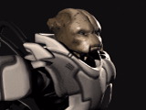

Terran-Vasudan communication was relatively easy to establish, despite the fact that Vasudan vocal cords are unable to make the sounds needed to produce the English language (now refered to as “Terran Standard” by spacers). This requires the use of small translational devices during any T-V exchange. The speaker talks in a low tone near the “squawker” and it translates and speaks for the user in the desired language. Small earpieces allow the devices to relay the opposite translations to the user. While the squawkers work on both species, the Vasudans are typically the ones to wear the devices.

Human archeologists and geologists have often been amazed that Vasuda Prime was capable of producing an intelligent species like the Vasudans. The planet is nearly completely covered by wind-blown deserts and barren, rocky terrain. As a result, Vasudans live mostly in domed, sheltered, or underground cities. Vasudans have, of course, always excelled at excavation and the efficient use and transport of resources. It’s also been speculated that Vasudans were originally forced prematurely into space in order to gain the resources needed for their species’ survival. Vasudans also excel at general engineering and efficient, high-speed ship propulsion systems.

Despite the physical differences between humans and Vasudans, their mentalities evolved very similarly. They have strong family structures, and enjoy many similar social activities that Terrans do. Parts of their not-too-distant history are shrouded in much ancient mysticism, and preoccupation with legends. So much so that it’s been often rumored that the Vasudan Parliamentary government actively discourages any remnants of such mysticism and fanatical religion.

It is suspected that the Vasudans may have actually been visited long ago in their past by another race, simply called “the Ancients”. Not much is known about this race, but from archaeological digs, it seems that they originated from a system nearby to Vasuda Prime. Since it is unlikely that Vasuda Prime could have sustained a primitive race for long enough to develop space travel, it is not unfeasible that “the Ancients” may have helped Vasudan culture develop enough to allow them to survive.

However, all evidence of “the Ancients” is mysteriously cut off after a certain point in time, leading scientists to believe there was some kind of cataclysm which befell their culture. Other more religious groups claim that they were destroyed by a powerful cleansing force, and that the same would happen to the Vasudans when they became too prideful. They claim that the ancients left a prophecy detailing the destruction of themselves, and the subsequent destruction of the Vasudans. Most modern Vasudans have abandoned this mythos, and believe that “the Ancients” were just another spacefaring race that stayed in the area for awhile, then moved on to more fertile systems.

The Temple at Altair, a massive ruins of what may have once been an Ancients’ building, stands on Altair 5, a liveable planet in a system not far from Vasuda Prime. This “temple” has been reconstructed into the headquarters for the “Hammer of Light”, which is a group of the most fanatical believers in the “Omen of Darkness” which is the term they have given to the eventual destruction of the Vasudan race. The Hammer of Light believes that only by staying steadfast and abandoning pride can they truly step into the Light and become one with their maker. Hence, they are a “Hammer of Light”, pounding in the values that they believe will help others see this light.

Due to the fact that the Vasudans were the first sentient species that the Terrans encountered in space, the Terrans adopted a naming convention based on Zodiac signs and constellations for Vasudan ships.

Shivans

Not much about the Shivans is known. Their complete disdain for planets and colonies has led most to believe that the Shivans do not live on planets at all. Their origins are unknown, however, it is possible that they were the cause of the destruction of “the Ancients”. Their technology is far more advanced than the other two cultures, and their anatomy is totally dissimilar. They have only been seen in zero-G environments where they use their three large “legs” to propel themselves. They also have two top “arms” which are primarily used for balance and guidance. They have numerous arachnid-like eyes on their well-protected heads.

The Shivan’s familiarity with Jump Node locations and their desire to gain control of them leads Terran Intelligence to believe that they know more about FreeSpace than anyone else.

Ship Specs

Fighters & Bombers of the Galactic Terran Alliance (GTA)

GTF Apollo
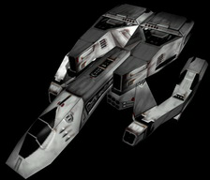
The Apollo fighter is the original Space Superiority Fighter in the Terran fleet. It is the first ship granted to commissioned GTA pilots and the easiest to use. With two secondary banks, it also can be used as a substitute for Assault, and thus is the most versatile ship. It's not as fast as the Ulysses or as maneuverable, and after the availability of the Ulysses, this ship will most likely collect dust. It has the least weapon
compatibility out of any ship, which is its primary disability. This ship does have a slightly better hull and shields than the Ulysses.

GTF Ulysses
Developed by Vasudans and Terrans working together after the reluctant close of the 14 year T-V war. It is the best all around fighter that the Terrans get. Its primary role is space superiority, and its one major flaw is a lack of a big secondary payload. It is used in missions such as patrols, escorts, cover for assaults. Its maneuverability is great. Its speed is second only to the interceptor (GTF Valkyrie). It can't hold the
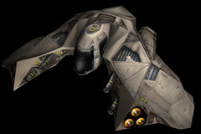
Banshee or the Phoenix, or any bombs, but otherwise it has access to all weapon systems. Due to its engine configuration, this fighter can yaw faster than any other ship.

GTF Valkyrie
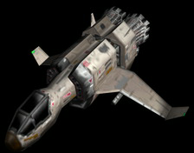
Originally an old design for a space superiority fighter, this fighter was outfitted with bigger engines, and turned into an interceptor. Its primary purpose, and one it excels at, is intercepting bombers, and it can get to, and destroy, bombers faster than any other ship. It only has one secondary payload bay and only one primary, which makes it far worse at dogfighting than most ships. However, this is compensated by its excellent payload capabilities. It can carry any primary weapon and any missile, most notably the Phoenix, which wreaks havoc on enemy bombers. Learning to fly this ship well requires intelligent use of its excellent speed.

GTF Hercules
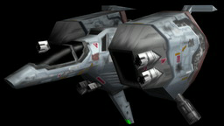
AKA "The Big Momma". This is the Terran Heavy Assault Fighter. Its stopping power is second to none. A wing of four of these ships has been known to take out a Vasudan Aten Cruiser all by their lonesomes. While they can't hope to bring the full muscle of a bomber class ship against targets, this is as close as you can get without losing the ability to win a dogfight. With a load of 6 primary lasers and two full secondary banks, as well as the ability to carry almost any warhead or gun, the low speed and maneuverability of this fighter can be overlooked when it comes to quality destruction power. This ship also has the strongest shields and hull of any other Terran fighter.

GTB Athena
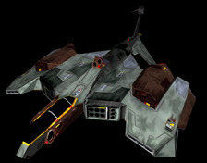
Dubbed the "lightning bomber" by some of its pilots, this little wonder was the mainstay of the GTA fleet before it started developing its bigger warheads. While it doesn't have nearly as much capacity for bombs or the hull strength of its younger brothers, it is still in use today for quick hit and run strikes. Its relatively small frame is carried well by its fast engines, allowing it to achieve speeds even greater than the Terran
Heavy Assault Fighter. While this bomber it pretty useless against the bigger ships, it definitely hasn't outlived its usefulness against transports and freighters. Its massive afterburner fuel reserve is its biggest advantage, its lack of good primary and anti-fighter secondary weapons, its biggest weakness. This bomber is also suitable for disabling a craft.

GTB Medusa
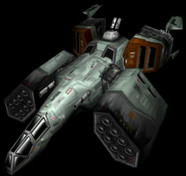
The Medusa is the current standard issue strike bomber. It can be deployed against small targets and large, and has the ability to take out lots of little stuff, or a few big stuff. It is your typical mediocre bomber, and
is used whenever available against the cruisers and freighters of the enemy. It has the ability to carry every current GTA secondary but the Harbinger, but its primaries are limited. Its speed isn't horrible, but
its maneuverability leaves much to be desired. Its main weakness is its lack of disabling weapons. This bomber is meant for destruction only. As it doesn't have much anti-fighter abilities (only one primary bank), it is imperative that any operations with this bomber be covered by a fighter escort. Its single turret can only protect it for so long.

GTB Ursa
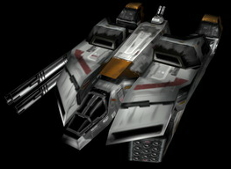
This is the biggest bomber in the Galactic Terran Alliance. With the ability to carry almost any weapon, it is almost always the weapon of choice when you just have to take out every Cruiser in the star system. This is THE Assault Bomber. With a length of 41 meters and a mass that dwarfs even the biggest of fighter-class ships, this hunk of metal can barely get enough engine power on default settings to enter subspace. While the armor and shields on this ship are the best in the Terran fleet, this craft is still just a sitting duck against enemy interceptors. Flying this ship requires either a lot of courage, or a lot of faith in your escort wing. And it's guaranteed there will be an escort wing. These ships cost more to make than it takes to buy a small moon. This is the only ship that can carry the devastating Harbinger bomb. It's a little
known fact that the Harbinger was designed specifically for this angel of death.

Other Vessels of the GTA

GTFR Poseidon
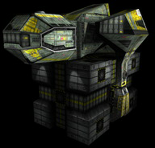
The Poseidon was designed for military purposes, and is easily the strongest freight craft in the fleet. Its fast speed and good maneuvering are offset by its weak hull. It does have enough turrets to defend itself
if attacked, but not for long. It's best to let this freighter help you out while you take the hits on your own shield, rather than risking the destruction of this ship.

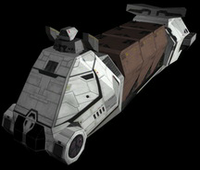

GTFR Chronos
The massive Chronos was never designed for military uses. A civilian design, it's slow, barely maneuverable, but can move cargo around. It can barely defend itself. It's far weaker in all respects than the smaller military freighter, but its strong hull and necessity have turned this into a pretty good supply convoy craft. You can leave this thing alone for a few minutes with no risk of it being destroyed.

GTT Elysium
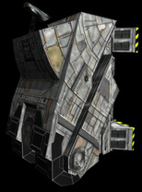
Since the start of space colonization, the standard transport has been used by everyone, civilian and military. While it has undergone minor changes time and time again, it remains a simple design: A vehicle meant to transport personnel from one place to another. While armored, they die easy, so watch out.

GTC Fenris
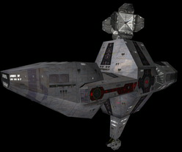
Ahh, what can we say about the mighty Fenris Cruiser? The mainstay of the Terran Fleet, these vessels have served in both strike and defense purposes. From nose to tail it measures 260 meters. With a nice array of weapon systems and a strong enough hull to withstand the strongest enemy warheads, a Fenris Cruiser can be found in almost any system that the GTA are operating in. The Terran cruiser was originally designed as a strike weapon, hence its fast speed and decent turning rate. It was later decided that a second line of cruisers would be produced, for defensive purposes, once it became apparent that the V-T war wouldn't be over in a few months. The Fenris led to the GTC Leviathan line of cruisers, produced as mobile defense battleships. Their speed and maneuverability were greatly reduced in tradeoff for stronger weapons and more powerful hull. Production was discontinued when the GTA thought they would win the Vasudan war after the Battle of Gulnara, and then the production was started up again after the terrible defeat at the Talania system. Because of the on-again off-again nature of this vessel's production, almost all of the Leviathan Cruisers have different armaments, but all of them have consistent hulls and speeds.

GTSC Faustus
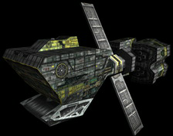
The Faustus Science vessel was, and still is, a primarily civilian craft. However, in the 14 years since the Terran-Vasudan war began, more and more of these were commissioned by the GTA in order to pursue military research. However, its obvious value, poor fighting capabilities, and lack of speed
make it a prime target for enemy ships; hence, you will rarely find many of these anywhere near the front lines of battle.

GTD Orion
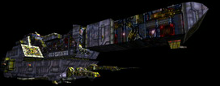
The mother of all Terran ships. Measuring a frightening 2.1 kilometers in length, the cost to build one of these far outweighs the cost of paying the crew of this ship for 3 years. There is no more important symbol of Terran Pride than a ship like the Galatea or the Intrepid cruising past a colonized planet, patrolling the system and ensuring safety. In the course of the 14 year war, very few of these have ever been lost, and each that one was considered a horrid defeat. While a temporary stay makes any inhabitants of the system happy, a prolonged tour of duty in a system instills fear into the hearts of civilians. For the GTA would never send a Orion Destroyer anywhere near a safe system. Where these ships wander, war is certain to follow.

GTI Arcadia
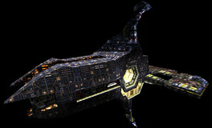
Early Terran space stations were constructed much smaller, and were mostly used for zero-G research purposes. Later on, with advancements in space construction technologies, stations got bigger and bigger. When the first Arcadia-class station was commissioned, GTA decided to rename it to an Installation rather than a Space Station. Used for a variety of purposes, almost all major systems are home to at least one Installation, which is often used as the center of trade and and communications. Home to scores of small ship, including repair vessels, fighters, and transports, an Arcadia class Installation is always a safe haven for a convoy of attack ships, returning from battle. Where the Orion is the symbol of Terran
power, the Arcadia is the shining beacon of stability.

TERRAN/VASUDAN WEAPONS:

Primary (Energy-based Cannon) Weapons

GTW ML-16
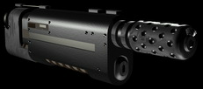
Argon laser weapon; uses transparent ceramic technology in order to create an optical system that is extremely durable and stable under battle conditions; provides adequate destructive damage to the hull of enemy ships by vaporizing molecular bonds at the target area and destabilizing molecular bonds across the grain of the hull material.

GTW-41 Disruptor Cannon
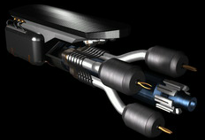
A gas-focused krypton laser; when the ship is in flight, the chamber of the GTW-41 rotates at a constant speed; a small amount of NO2 is injected into the container .05 ms prior to the emission of the laser
light; the rotation of the NO2 in the chamber focuses the laser pulse to a state that is only very slightly (1%) diffused; after the laser pulse is emitted from the chamber into space, the chamber expels the NO2 into space (thus expelling ionized molecules and moisture); the process repeats for each subsequent burst of laser energy; as this laser is very slightly diffused, it is not effective as a destructive weapon, but as a tactical weapon; the Disruptor Cannon is best suited and is used for the permanent disabling of enemy ship subsystems.

GTW-15 Avenger
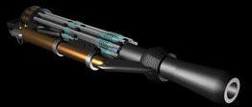
A rapid-fire, computer-controlled radar and gun system; capable of firing at a rate of more than 4500 rounds per minute; used primarily for close-defense situations; uses closed-loop radar technology to locate,
identify, and direct a stream of highly destructive 45mm projectiles to the target.

GTW - 32 Flail
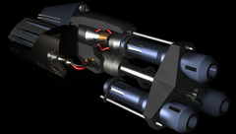
A rapid-fire, low energy, ceramic optic focused, krypton laser; used in tactical situations to distract or lead an enemy to their destruction at the hands of other allied fighters; this weapon, if used over an
extended period of in-flight battle, can destroy an enemy fighter, but, as a destructive weapon, should only be used as a last resort.

GTW - 5 Prometheus
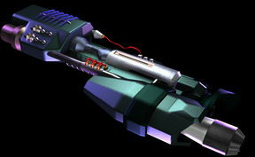
Named after the Titan who gave fire to humanity, the Prometheus is a laser-based weapon; an advanced radar and X-ray tracking system lock on the target and determine the target’s material structure; argon laser
focused via transparent ceramic optics; uses only slightly more energy than the GTW ML-16; the laser is generated at the destructive frequency (full out-of-phase) for the target’s material structure; emitted no more than .02 ms after targeting and activation by the pilot, the Prometheus stands as one of the GTA’s most effective deterrents to enemy attack, an effective form of defense for GTA pilots, and as a durable, portable, and highly destructive offensive tool.

GTW - 7 Banshee
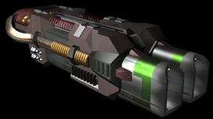
An electromagnetic weapon; sends rapid pulses of exceptionally strong electromagnetic energy resulting in a 1.63 x 105 J blast that forces its way through any known shield technology and produces a dramatic shearing effect which quickly destroys the target ship’s materials; named for the fact that in an atmosphere, the pulse creates an atmospheric disturbance similar to a quasi-human scream at 180 dB; uses up a tremendous amount of available ship energy; already, it is has been used by many GTA fighter aces and test pilots as a coup de grace, although such a use for this massively powerful offensive weapon is officially viewed as poor sportsmanship by the GTA.

Secondary (Missile-based) Weapons

GTM MX-50
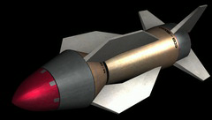
Available for all space battles, defensive and offensive; medium payload (16.5 Kt); infrared tracking and semi-intelligent targeting; pilot chooses desired target, and the MX-50 tracks the chosen target based off the emission of heat from the engine, the weapon bays, and the cockpit of the target ship; the MX-50 will always attack a target that is determined to be hostile by the onboard computer of any GTA combat vessel, thus ensuring a higher kill rate, should the pilot find himself in a heated battle situation where precise aiming might be difficult.

GTM - 31 Disruptor Missile
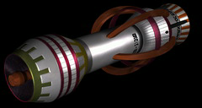
Advanced signal processing; high precision interception capability; small payload (9 Kt), combining both conventional explosives and a localized blast of energy caused by the effect of impact upon the laser-propulsion system of the missile; designed to temporarily disable subsystems on hostile targets.

GTM - 2 Fury
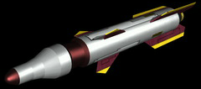
Small, fast dumbfire missiles; fired in swarms; GTA fighters can carry more Fury missiles than conventional missiles, due to their small size; used for distraction and other tactical measures; very small payload (3 Kt).

GTM - 4 Hornet
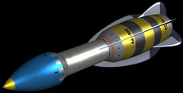
Infrared and ultraviolet tracking; designed to fire in small groups of 4 missiles per burst; light medium payload per missile (12 Kt); semi-intelligent on-board tracking; single-pass kill probability will not
exceed 60% on average; designed as an offensive version of the Fury.

GTM - 9 Interceptor
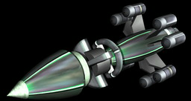
All-aspect seeking; laser tracking senses energy reflected off a target from the primary weapon systems of the target, increasing single-pass kill probability; medium payload (18.5 Kt); missile is designed to pierce
reinforced hull, thus securing itself to the target, prior to detonating (15 ms delay).

GTM Phoenix V
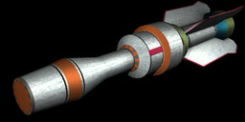
All-aspect seeking; same tracking system as the Interceptor; large payload (50 Kt), but somewhat slower than the Interceptor; one of the best fire-and-forget missiles ever developed; many fighter pilots within the GTA regard the Phoenix V as the weapon of choice against high value, heavily defended targets.

GTM - 1 Synaptic Bomb
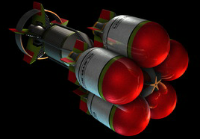
Missile propulsion unit carrying several small intelligent "bomblets"; when distance to target is less than 100 m or when time to impact is less than 2 sec., bomblets direct missile to the most vulnerable part of the ship of those parts of the ship facing the missile; bomblets then separate from missile propulsion unit and form a sphere; inertia continues to carry bomblets in the direction of the target; the missile propulsion unit
continues to advance toward the target; when the missile hits the target or 1.5 sec. after the missile should have hit the target, the bomblets explode; the spherical shape of the formation of the bomblets helps to ensure a fairly even level of damage across a sensitive area on the target; the spherical shape also ensures that the target will not be able to effectively maneuver away from the blast, thus "pinning" the target to a specific area in space; can also act as dumbfire; medium payload per bomblet (15 Kt); very small payload for missile (2 Kt).

GTM - 43 Stiletto
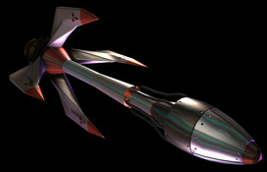
All-aspect seeking; laser tracking similar to the Interceptor; missile is protected by a small shield system, allowing for greater success in payload delivery during busy melee situations and intense firefights; fast, but low in-flight maneuverability compared to other missiles of comparable size; low maneuverability due to the size of the missile’s payload (60 Kt) and on-board shield system.

GTM - 3 Tsunami
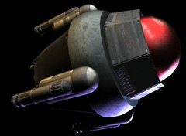
Intelligent tracking similar to GTA targeting system; prior to launch, communicates with ship computer, gathering data about enemy target types and whereabouts; slow, low maneuverability; antimatter warhead (500 tonne3 mass-to-energy conversion); due to instability of antimatter, no more than 6 may be carried on board a GTA bomber at any given time, unless pilot is granted a special permit by an appropriate governing body or pilot is to participate in a glory mission.

GTM - N1 Harbinger
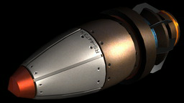
Fusion bomb surrounded by 3 salted fission bombs; propulsion unit is a half-size version of a regulation GTA fighter thruster (Class II); given the weight of the payloads, the missile is slow despite the power of the thruster; as the Harbinger is exceptionally large, GTA fighters and bombers are limited to carrying 2 of these weapons at any given time; the resultant shock wave from this weapon is potentially deadly, due to the size of the payloads (5000 Mt in total); use near allied installations or allied ship groupings is strongly discouraged by the GTA; most effective when used in preemptive defensive strike against non-military installations.

